Contents
Collections

Collections
Collection is a group of objects.

Collection Interfaces & Implementations

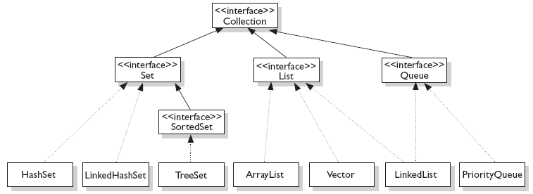

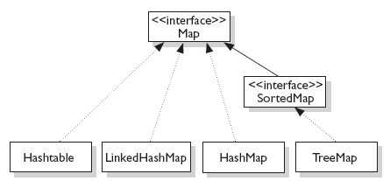
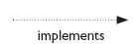
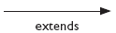
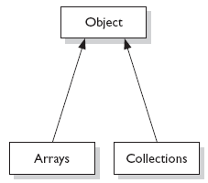

Various Collections
Factors | Key-value or only values | Ordered or Sorted | Duplicates  (Y/N) | Null values | Synchronize (Y/N)
ArrayList  [Growable & powerful than String] | values | Ordered | Yes | Yes | No. Therefore, faster than vectors
HashSet  [Uses hashcodes ] | values | Not sorted, Not Ordered | No | Single null value | Yes
TreeSet | values | sorted | No |  | No
HashMap  [Uses hashcodes ] | Key-value | Not sorted, Not Ordered | Unique key. Duplicate values allowed | one null key & multiple null values | No
TreeMap | Key-value | Sorted on keys | Duplicate values allowed | No null key. One null value | No
LinkedHashMap | Key-value | Ordered
LinkedHashSet | values | Ordered
Vector | [growable & used instead of arrays] |  |  |  | Yes
HashTable  [Uses hashcodes ] | Key-value | Not sorted, Not Ordered | Duplicate values allowed | No null key. No null value | Yes

Collection Methods
int size(); | Returns number of elements in collection
boolean isEmpty(); | Returns true if collection is empty
boolean contains(object element); | Returns true if element is present in the collection
boolean add(object element); | Adds element to collection
boolean remove(object element); | Removes element to collection
Iterator iterator(); | Returns and iterators from the collection
void clear(); | Removes all elements from collection

Autoboxing & Unboxing
 | Prior to Java 5 | Since Java 5
Boxing | int iVal = 11;  Integer iRef = new Integer(iVal); | int iVal = 11;  Integer iRef = iVal;
Unboxing | int iVal = iRef.intValue(); | iVal = iRef;

